Chapter 16, Problem 76.

For the circuit in Fig. 16.95, find H(s) = V_{o}(s)/V_{s}(s). Assume zero initial conditions.

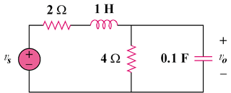
kv_{s}

Figure 16.95
For Prob. 16.76.

